H.T No
Regulations:
A22

Sreenidhi Institute of Science and Technology
(An Autonomous Institution)
Code No:9K301 Date: 12-September-2024 (FN)

B.Tech II-Year I- Semester External Examination, September -2024 (Supplementary)
STRENGTH OF MATERICALS (CIVIL)

Time: 3 Hours Max.Marks:60

Note: a) No additional answer sheets will be provided.
b) All sub-parts of a question must be answered at one place only, otherwise it will not be valued.
c) Missing data can be assumed suitably.
Bloom's Cognitive Levels of Learning (BCLL)

Remember | L1 | Apply | L3 | Evaluate | L5
Understand | L2 | Analyze | L4 | Create | L6

Part - A Max.Marks: 6x2=12

Answer all QUESTIONS, EACH QUESTION CARRIES 2 MARKS.

 |  | BCLL | CO(s) | Marks
1 | Define Stress at a point in a material, and mention its units. | L2 | CO1 | [2M]
2 | Draw shear force diagram for a simply supported beam of length L carrying a uniformly distributed load of w per unit length over its entire span. | L3 | CO2 | [2M]
3 | Draw the bending stress and shear stress profiles for a rectangular beam section. | L3 | CO3 | [2M]
4 | Write the expression for shear stress in a section of beam and explain the terms | L1 | CO4 | [2M]
5 | What do you understand moment area method? | L1 | CO5 | [2M]
6 | What is Mohr’s circle. | L1 | CO6 | [2M]

Part – B Max.Marks: 6x8=48
ANSWER ALL QUESTIONS. EACH QUESTION CARRIES 8 MARKS.

 |  | BCLL | CO(s) | Marks
7. | A member ABCD is subjected to point loads P₁, P₂, P₃ and P₄ as shown in figure below. Calculate the force P₂ necessary for equilibrium, if P₁ = 45kN, P₂ = 450kN and P₄ = 130kN. Determine the total elongation of the member, assuming the modulus of elasticity to be 2.1x10⁵ N/mm².  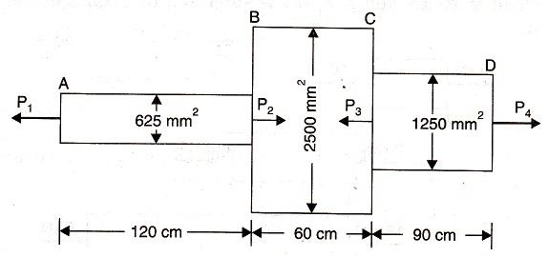 | L2 | CO1 | [8M]
 | OR
8 | A prismatic bar of length l and unit weight w is suspended freely from its end. Determine the elongation of the member under gravity. | L2 | CO1 | [8M]
9. | A beam of length 20m is simply supported and carries point loads of 10 kN each at a distance of 6m and 14m from the left end and also a uniformly distributed load of 2 kN/m between the point loads. Draw the S.F and B.M diagrams for the beam. | L3 | CO2 | [8M]
 | OR
10 | A simply supported beam of length 16m rests on supports 12m apart, the right hand end is overhanging by 4m. The beam carries a uniformly distributed load of 3000N/m over the entire length. Draw S.F and B.M diagrams and find the point of contraflexure, if any. | L3 | CO2 | [8M]
11. | Three beams have the same length, the same allowable stress and the same bending moment. The cross-section of the beams are a square, a rectangle with depth twice the width and a circle. If all the three beams have the same flexural resistance capacity, then find the ratio of the weights of the beams. Which beam is most economical? | L2 | CO3 | [8M]
 | OR
12 | A hollow square section with outer and inner dimensions of 50 mm and 40 mm respectively, is used as a cantilever of span 1 m. How much concentrated load can be applied at the free end, if the maximum bending stress is not exceed 35 MPa? | L3 | CO3 | [8M]
13. | Show that the ratio of maximum shear stress to mean shear stress in a rectangular cross-section is equal to 1.50 when it is subjected to a transverse shear force F. Plot the variation of shear stress across the section. | L2 | CO4 | [8M]
 | OR
14 | Show that for a rectangular section of the maximum shear stress is 1.5 times the average stress | L2 | CO4 | [8M]
15. | A beam of length of 6 m and of uniform rectangular section is simply supported at its ends. It carries an udl of 12 KN/m runover the entire length. Calculate the width and depth of the beam if permissible bending stress is 9 N/mm² and maximum deflection is not to exceed 1.25 cm. Take E for beam material = 1.05 x 10⁴ N/mm². | L4 | CO5 | [8M]
 | OR
16 | A cantilever AB, 4 m long, is carry a load of 30 KN at free end and 50 kN at a distance of 2 m from the free end. Find the slope and deflection at the free end using conjugate beam method. Take E= 200 GPa and I= 150X10⁶ mm⁴. | L4 | CO5 | [8M]
17. | Evaluate the principal stresses and principal planes for the state of stress as shown in the figure below.  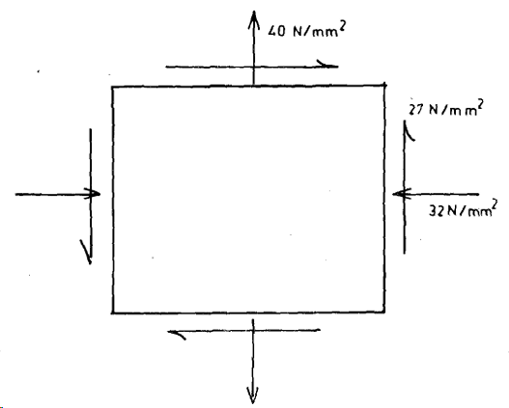 | L4 | CO6 | [8M]
 | OR
18 | The state of stress at a point in a loaded solid is prescribed on two faces of an element whose shape is a triangular prism as shown in Figure below. Evaluate the principal stresses and principal planes.  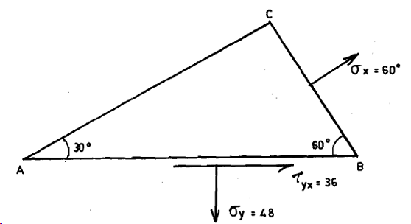 | L4 | CO6 | [8M]

-- 00 -- 00 –

